- Topic : machine language & neural netwok
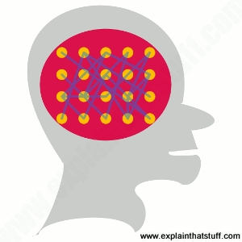

Introduction :

- Natural language processing is how machine understand human language as a branch of artificial intelligence the field of natural language processing (Nlp) plays in important part in making interaction between human and computer easier.

  - Defination in details
By crisis wood ford. Last updated:
30 August,2021.

Which is better computer and brain?
Asks most people if they want a brain like a computer and they'd probably jump at the chance. but look at the kind of work scientists have been Over the last couple of decades and you’ll find many of them have been trying hard to make their computers more like brain How? with the help of neural network - computer program assembled from 100,000 or million of artificial brain cells that learn and behave in a remarkably similar way to human brain. what exactly are new learn neural network how do they work? let’s take a closer look!

- How brain differ from computer
You often hear people comparing the human brain and the electronic Computer and neuron on the face of it they do have thing in common . A typical brain contain something like 100 billion minuscule cells called neurons (no-one know exactly How many there are end estimates go from about 50 billion to as many as 500 billion).

- [1] Each neuron is made up of cell body (the central mass of the cell) With our number of connection coming off it: neurons dentrites the cell input-carrying Information towards the cell body)And a single Axon (The cell's Output - crying information away). Neurons r show t need that you could pack about 100 of their cell bodies into a single millimetre.(It’s also worth noting briefly in passing dad neurons make up only 10 - 50 of all the cells in the brain; The rest are galil cells also called neuroglia, that support and protect the neurons and feed them with energy that allow them to work and grow.)

- [1] Inside a computer, the equivalent to a brain cells is a nanoscopically switching device code are transistors the list cutting edge microprocessor (single chip computer)Contain over 30 billion transistors; Even a basics Pentium microprocessor from about 20 years ago had about 50 million transistors, all packed onto an integrated circuit just 25 mm square (smaller than a postage stamp)!

- [2]…. Artwork: A neuron the basic structure of end brain cell showing the central cell body the dentrites(Leading into the cell body), And the Exxon (leading away from it ),

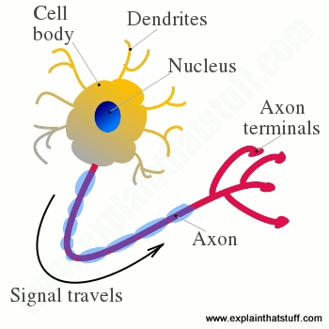

- That’s where the comparison Computers and brain And ends because the two things Are completely different. It’s not just that computer are cold metal box stuffed full of binary numbers, while brains are warm, living things packed with thought , feeling , and memories. The real difference is that computers and brains “think” in completely different way. The transistors in a computer are wired in relatively simple, serial chains (each one is connected to May be two or three others in basic arrangements known as logic gates), whereas the neurons in brain are densely interconnected in complex, parallel ways (each one is connected to perhaps 10,000 of its neighbors.

- the essential structural difference between computer (with maybe a few 100 million transistor connect in a relatively simple way) and brain (perhaps 10-1000 times more brain cells connected in richer and more complex ways) is what makes them “think” So very differently. computer are perfectly designed for storing vest amount of meaningless (to them) information and rearranging it in any number of ways according to precise instruction (program) We feed into them in advance. brain on the other hand, by a more round about method, often taking month of year to make complete sense of something really complex. But, unlike computers, they can spontaneously put information together in astounding new ways- that’s where the human creativity of beethoven or a Shakespeare comes from- recognizing original pattern, forging connection, and seeing the thing they've learn in a completely different light.

- Wouldn’t it be great if computer were more like brains? that’s war neural network come in!
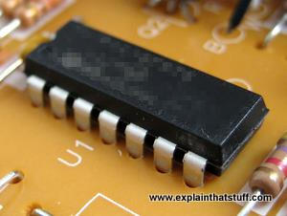

- Electronic brains? not quite. computer chips are made from 1000, million and sometime even billion of tiny electronic switches called transistor. that sounds like a lot, but there are still far fare of them then there are cells in the human brain.

What is a neural network ?

- The basic idea behind a neural network is to simulate (copy in simplified but reasonably faithful away) lots of dance Lee interconnected red cells inside a computer so you can get to learn things recognise pattern and make decision in a humanlike way. the Think about a neural network is that you don’t AB to program it to learn explicitly: it learn all by itself, just like a brain!

But it isn’t brain it is important to note that neural network (generally) software simulation: they’re made by programming very ordinary computers, working in a very traditional fashion with their ordinary transistors and serially connected logic gates, To behave as they’re bullet from billion of highly Brain cell working in No one has at attempt to build a computer by wiring up transistor in a dansely parallel structure exactly like the human brain. In another words , a neural network differ from a human brain in exactly the same way that a computer model of the weather Differ from real clouds, snowflaks, or sunshine computer simulation are just collection of algebraic variables and mathematical equation linking them together (in other words number stored in boxes whose values are constantly changing). They means nothing whatsoever to the computer they ran inside- only to the people who programmed them.

Real and Artificial neural network

Before we go any further it’s also worth nothing some Jagron. Strictly speaking neural networks products this way are called artificial neural networks. (Or DNAs) Pull out to differentiate them for the real neural networks (collections of interconnected brain cells)We find inside our brains you might also shared neural networks refer to by names like connectionist machine (the field is also called connectionism), Parallel distributed processor network(PDP), thinking machine and so on- but in this article we’re going to use the term “neural network” throughout an always use it to mean “artificial neural network”.

What does a neural network consist of

A typical neural network has anything from a few dozen to hundreds, thousands, or even millions of artificial neuron called unit arranged in a series of layers each of connect to the layers on either sides. Some of the known as input units are designed to receive various forms of information from the outside world that the network will attempt to learn about, recognize, or otherwise process. other unit site on the opposite side of the network and single how it respond to the information its learned those are known as output unit. In between the input units and output units are one or more layer of hidden units, which together, from the majority of the artificial brain. most neural networks are fully connected, Which means each hidden unit and each output unit is connected to every unit in the layers either side. the connection between one unit and another are represented by number called weight, Which can be either positive (if one unit exit is another) or negative (if one unit soup recipes or in hibbitts another.) the higher the weight the more influence one unit as on another (this corresponds to the way actual brain cells trigger one another across tiny gaps called synapses.)
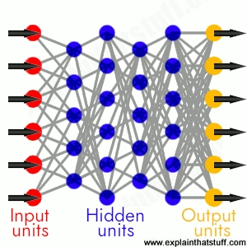

- A fully connected neural network is made up of input units (red),hidden units (blue), and output units (yellow), With all the units connected to all the unit in the layers either side input are fed in the form the left activate the hidden units in the middle and make outputs feed out from the right the strength (weight)

Summary :

A neural network is a graph of neurons. A neuron has inputs and outputs. Similarly, a neural network has inputs and outputs. The inputs and outputs of a neural network are represented by input neurons and output neurons.

**************The End ************

Name: - Mannu prasad
Class:- 9th ‘D’
Subject:- IT Project Work
Topic:- Machine language and Neural Network
Respected subject Teacher:- Praveen Joshi, Sir
Date:- 10/oct/2021
School:- Ever Green Sr. Sec. School

*************Thank you ***********

References

- Jing, L., Ming, L., Bin, Y., Wenlong, L., A Novel Energy Efficient MAC Protocol for Wireless Body Area Network. China communication, Feb. 2015.
- Negra, R., Jemili, I., Belghith, A.: Wireless Body Area Networks: Applications and Technologies. Procedia Computer Science 83, 1274 – 1281 ( 2016 )
- Yuce, M.R.: Implementation of wireless body area networks for healthcare systems. In: Sensors and Actuators A: Physical, Vol 162, Issue 1, Pages 116-129. Elsevier B.V (2010)
- Dabhi, K., Mahet, A.: Internet of Nano Things-The Next Big Thing. In: International Journal of Engineering Science and Computing, vol 7 Issue No.4 (2017)
- Negra, R., Jemili, I., Belghith, A.: Wireless Body Area Networks: Applications and Technologies. Procedia Computer Science 83, 1274 – 1281 ( 2016 )
- Yuan, X., Li, C., Ye, Q., Zhan, K., Cheng, N., Zhan, N., Shen, X.: Performance Analysis of IEEE 802.15.6-Based Coexisting Mobile WBANs with Prioritized Trafﬁc and Dynamic Interference. In: IEEE Transactions on Wireless Communications (Volume: 17, Issue: 8, Aug. 2018)
- Adhikary S., Chattopadhyay S., Choudhury S.: A Novel Bio-inspired Algorithm for Increasing Throughput in Wireless Body Area Network (WBAN) by Mitigating Inter-WBAN Interference. In: Chaki R., Cortesi A., Saeed K., Chaki N. (eds) Advanced Computing and Systems for Security. Advances in Intelligent Systems and Computing, vol 667. Springer, Singapore (2018)
- Peng, H., Tian, Y., Kurths, J., Li, L., Yang, Y., Wang, D.: Secure and energy-efﬁcient data transmission system based on chaotic compressive sensing in body-to-body networks. IEEE Trans. Biomed. Circ. Syst. 11(3), 558–573 (2017)
- Samanta, A., Misra, S.: Energy-efﬁcient and distributed network management cost minimization in opportunistic wireless body area networks. IEEE Trans. Mobile Comput. 17, 376–389 (2017)
- Ahmad, S.S., Razzaque, M.A., Inmaculada T.R., Hussain, N.: IEEE 802.15.6 Standard in Wireless Body Area Networks From a Healthcare Point of View. The 22nd Asia-Pacific Conference on Communications (APCC2016)
- Yi, C., Wang, L., Li, Y.: Energy efﬁcient transmission approach for WBAN based on threshold distance. IEEE Sensors J. 15(9), 5133–5141 (2015)
- Misra, S., Moulik, S., Chao, H.-C.: A cooperative bargaining solution for priority-based data-rate tuning in a wireless body area network. IEEE Trans. Wirel. Commun. 14(5), 2769–2777 (2015)
- Walsh, M.J., Hayes, M.J.: Throughput rate control for an 802.15.4 wireless body area network using static and low order anti-windup techniques. In: Proc. Mediterranean Conf. Control Autom, pp.1–6 (2007)
- Eberhart, R., Kennedy, J.: A New Optimizer Using Particle Swarm Theory. Sixth International Symposium on Micro Machine and Human Science, 0-7803-2676-8/95
- Kalaiselvi, K., Suresh, G.R. & Ravi, V.: Genetic algorithm based sensor node classiﬁcations in wireless body area networks (WBAN). Cluster Comput (2018)
- Nadeem, Q., Javaid, N., Mohammad, S.N., Khan, M.Y., Gull, M.: SIMPLE: Stable Increased-throughput Multi-hop Protocol for Link Efﬁciency in Wireless Body Area Networks. 26, Jul. 2013.

